**# How to Use Get-AzureAdUserNew Module as cmdlet**

Run the entire code and check examples to execute it

**Example1:- Using -ALL parameter (User True as switch parameter to get the result**

**Here “token.accesstoken” is fetch from connect-azuread command using graph API**

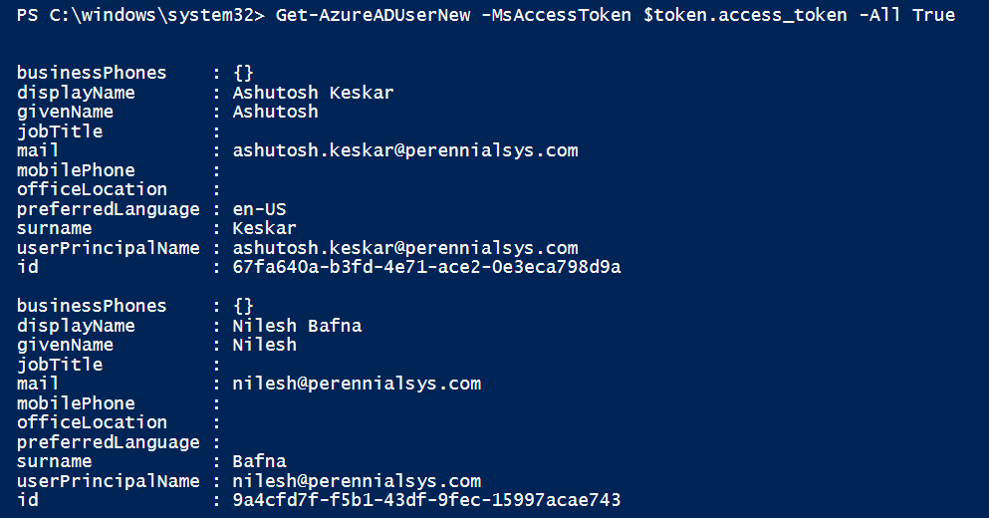

Example2:- Using Top parameter, -Top 1 will display the result of 1 object.

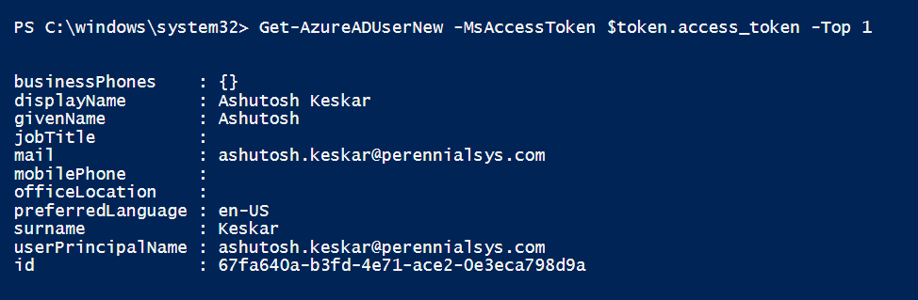

Example 3:- Using objectiD parameter, Used UPN as Object ID

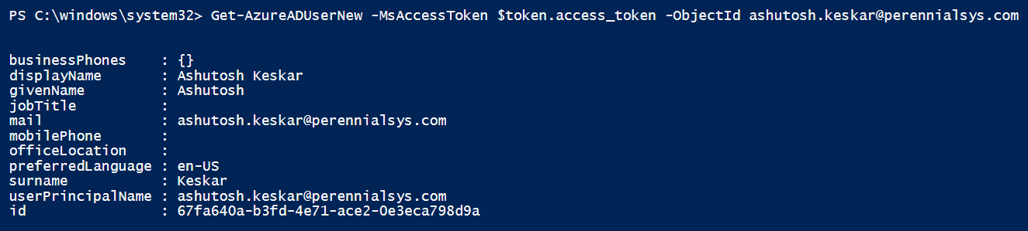

Example4:- Using SearchString parameter, here used searchsting as “ashutosh”

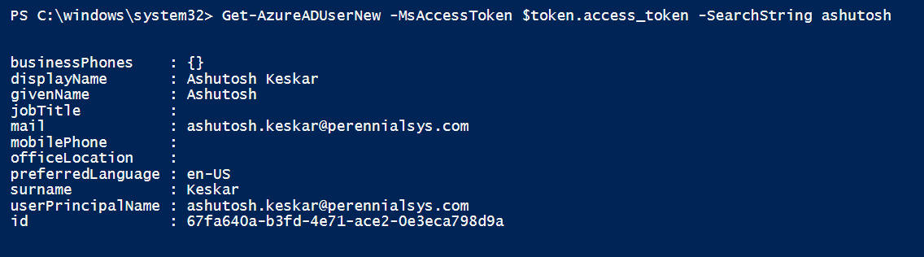

Note:- This is just an sample of cmdlet document.